**HCI Project**

**OSU Shuttle app**

**Project Part 3: Your Users**

**Team Members:**

Aswin Pratap Mullankandi

Dharun Narayanan Lakshminarayanan Komethagavelu

Santhos Kamal Arumugam Balamurugan

Sai Balaji Neeli

**The scenario being evaluated:**

Scenario 2:

*Abi needs to get to her doctor's appointment at the Benton County Health Services in afternoon after her classes. She opens the app and searches for routes that go between class from ILLC and Benton County Health Services. The app not only displays the schedule and route for the OSU shuttle system, but also integrates information about the Corvallis LBCC bus network. It shows Abi that she can take the orange OSU shuttle to a transfer point, then connect to a Corvallis bus that will take her directly to the Benton County Health Services. The app provides the estimated travel times for this combined shuttle and bus trip, as well as the number of transfers required. Considering factors like total travel duration and convenience, the app recommends this multi-modal route as the most efficient option for Abi's commute.*

**Research Questions**

* How does the user navigate the app to find the information she needs to get from classes at ILLC to her doctor's appointment at Benton County Health Services?
* What challenges or frustrations does the user encounter while using the app to plan her multi-modal route?

**Process**

* *Where and when did you collect the data?*

The observation and interview were conducted on May 3, 2024, from 1-1:30pm at the 3rd floor hallway of Learning Innovation Center (LINC) on the OSU campus.

* *How did you proceed to answer these questions? Be detailed. For example, did you interleave interview questions into the observation? Did you ask reflective interview questions after you observed them completing the scenario?*

We conducted a semi-structured interview. The interview process was divided into three main parts: rapport building, observation, and reflective questioning.

* + Rapport building:

We began the interview with casual questions to put Jane at ease and establish a comfortable atmosphere. These questions included asking about her day, her upcoming midterms, and her typical mode of transportation around campus. This helped create a friendly and open environment, encouraging Jane to share her thoughts and experiences more freely.

* + Observation:

Next, we asked Jane to demonstrate how she would use the OSU Shuttle app to plan her route from ILLC to Benton County Health Services after her classes. During this observation phase, we closely monitored Jane's interactions with the app, noting her navigation choices, facial expressions, and any verbal comments she made. We observed how she used the search bar, selected routes, and reacted to the information provided by the app. This gave us valuable insights into her thought process and any potential pain points or frustrations she encountered while using the app.

* + Reflective questioning:

After Jane completed the route-planning scenario, we transitioned into the reflective questioning phase. We asked open-ended questions to gain a deeper understanding of her experience and opinions of the app. These questions covered topics such as her favorite features, most frustrating aspects, and desired improvements. We also asked about her experiences with multi-modal trip planning and her thoughts on integrating OSU Shuttle and Corvallis bus information within the app.

* *What are the questions you asked during the interview?*
* Hi Jane, thanks for taking the time to meet with us today. How's your day going so far?
* That's great to hear! Do you have any midterms coming up this week?
* I'm sure you'll do great! So, I know you're a frequent user of the OSU Shuttle app. How do you typically get around campus?
* That makes sense. Having a bike must be nice for those quick trips. When you do use the shuttle, could you walk me through your typical experience with the OSU Shuttle app? What are the main tasks you try to accomplish with it?
* I can definitely relate to wanting to explore all the features of a new app. What do you find most useful or convenient about the current app? Are there any specific features that you rely on heavily?
* Those sound like great features. What aspects of the app do you find frustrating or difficult to use? Can you give me some specific examples?
* I'm sorry to hear about that crashing issue. That must have been frustrating and we all have faced it at some point. I'm curious about your thoughts on multi-modal trip planning. Let's say you're planning a trip that involves using both the OSU shuttle and the Corvallis LBCC bus system. How would you currently go about planning and navigating that kind of trip using the existing app?
* I can see how that would be inconvenient. If the app could provide integrated information and routing for both the OSU shuttle and Corvallis bus systems, how valuable would that be to you? What specific information or features would you expect from such an integration?
* Those are great points. It sounds like integrated trip planning would be a big improvement. While we're on the topic of navigation, what information or features are most important to you when it comes to route planning?
* That makes sense. Real-time info and clear directions are so important. Shifting gears a bit, how do you feel about the current app's interface and navigation? Is it intuitive and easy to use, or are there areas that could be improved?
* Those are great suggestions. I also wanted to touch on accessibility. Are there any specific accessibility features or improvements you would like to see in the redesigned app?
* Those are excellent points. Accessibility is so important. On a different note, can you think of a time when you had a particularly positive or negative experience using the current app? Could you give us an example of scenario and explain what made it a good or bad experience?
* Wow, that's quite a contrast in experiences. It's great to hear that the live map feature was so helpful, but I'm sorry to hear about the difficulty with the settings. If you could redesign or add any new features to the OSU Shuttle app, what would be your top priorities? What would your ideal version of the app look like?
* Those are fantastic ideas. I really appreciate your thoughtful feedback. Before we wrap up, are there any other transportation apps or services that you find particularly user-friendly or well-designed? If so, what aspects of those apps do you appreciate and would like to see incorporated into the redesigned OSU Shuttle app?
* Those are great examples. I'll definitely take a look at Citymapper and see what we can learn from their design. Before we finish up, do you have any other thoughts, suggestions, or concerns regarding the redesign of the OSU Shuttle app that we haven't covered yet?
* Absolutely. User involvement and testing are crucial for a successful redesign. And stability is definitely a top priority. Thank you so much, Jane, for taking the time to share your experiences and insights. Your input will be incredibly valuable as we work on redesigning the OSU Shuttle app to better serve students like you.
* Of course! We really appreciate your time and feedback. Enjoy the rest of your day, and best of luck with your biology midterm!

**An exhaustive inventory of the elements we discussed in class:**

**The people in the space**

1. *Who are they, what are they like?*

The person interviewed, Jane is a 1st-year undergraduate student in Department of Biological and Ecological Engineering from OSU, pursuing Ecological Engineering. She is highly motivated, goal-oriented, and interested in practical applications of her studies. The team members interviewing her are Aswin, Dharun, Santhos, and Sai. They are attentive, collaborative, and focused on gathering information about the user's experience with the OSU Shuttle app.

1. *What are they doing?*  
   Jane is using the OSU Shuttle app to plan her commute from ILLC to Benton County Health Services after her classes. Aswin is asking questions and noting down important points from her expressed thoughts. Dharun is giving a tutorial of what needs to done and clearing Jane's doubts and taking notes. Santhos and Sai are taking notes from proximity and from a distance, respectively.
2. *How are they doing it?*

Jane uses the app's features, such as the search bar and route selection options, to find the most efficient route for her commute. Aswin is actively listening to her thoughts and experiences, noting down key points. Dharun is engaging with the user, answering any questions she may have about the app or the interview process. Santhos and Sai are diligently taking notes, capturing different perspectives based on their proximity to the user and the conversation.

1. *What do their emotions, purposes, reactions seem to be?*

Jane’s emotions vary based on her experience with the app. Initially, she felt curious about its features and response time but became slightly frustrated with the difficulties in finding information such as the bus stops. However, she seems relieved when she finally planned her route. Her purpose is to efficiently plan her commute and attend her doctor's appointment, indicating a practical and goal-oriented mindset.

Aswin, Dharun, Santhos, and Sai appear to be engaged and focused on their respective tasks. They are working together to gather comprehensive information about the user's experience, with each team member playing a specific role in the interview process. Their purpose is to understand the user's perspective, identify pain points, and gather insights that can be used to improve the app's usability and functionality.

1. *What problems do they encounter with their activities?*

* Jane encountered difficulties in understanding complex route options or navigating the app's interface, especially as she is not familiar with similar apps. She also faced challenges related to time constraints or scheduling conflicts, as she is planning her commute around her classes and other commitments.
* The team members may encounter challenges in coordinating their efforts, ensuring that they are capturing all relevant information without overwhelming the user. They may also face difficulties in interpreting the user's responses or identifying underlying issues that may not be immediately apparent. Additionally, they may need to adapt their approach based on the user's comfort level and engagement with the interview process.

**The objects (technological and otherwise) in the space and with the people (2 pts)**

1. *What are the functional elements of the objects?*

Jane's smartphone (iPhone) and laptop (MacBook Air) running the transit app serve as the primary tools for accessing and using the OSU Shuttle app. The smartphone's GPS functionality is crucial for determining her current location (start point) for route planning. The app itself provides a route map with stops, transfers, and timings, as well as a list view of steps and timings for the recommended route. The search bar and filters on the app allow Jane to enter start/end points and adjust route criteria. There are two tables and six chairs being utilized in this meeting which serves its function and adds to the aesthetics.

1. *What are the decorative elements?*

The decorative elements of the smartphone and laptop are likely minimal, as their design is primarily focused on functionality. There are several stickers on the laptop. In the room hallway there are minimal decorations and minimalistic designs.

1. *Which objects do people look for (perhaps to somehow interact with)?*

Jane would primarily be interacting with her smartphone and laptop to use the transit app. She would be looking for these objects to access the app, enter her start/end points, view route options, and plan her commute. Additionally, she may refer to her paper planner for appointment details, indicating that this object is also important for her planning and scheduling activities.

1. *Which objects do people bring with them that matter to the activities they are trying to do?*

Jane brings her smartphone and laptop with her, as these are essential for accessing the OSU Shuttle app and planning her commute. The smartphone's GPS functionality is particularly important, as it determines her current location for route planning. Her paper planner is also relevant, as it contains appointment details that she may need to refer to while planning her commute.

**The environment: spaces, architecture, lighting etc. (2 pts)**

1. *What is the layout?*

The observation took place at a table in a semi-quiet corner of Linc. The layout includes seating areas with tables, possibly arranged in a way that allows for some privacy or separation from other activities in the space.

1. *What is the environment like?*

The environment is described as semi-quiet, with ambient noise and some visual distractions. Despite these distractions, Jane was still able to focus on the app. The lighting is described as decent, which made the app's visuals easy to see. Overall, the environment seems conducive to focused work or study, with a balance of noise and visual stimulation.

1. *How does it influence the activities people engage in?*

The semi-quiet environment, combined with decent lighting, likely helps people like Jane focus on their tasks, such as using the app to plan their commute. The presence of some visual distractions may be a minor inconvenience but does not seem to significantly impact Jane's ability to use the app effectively.

1. *How does the environment support the objects above?*

The table surface provided a convenient place for Jane to set down her phone and planner as needed, supporting her use of the smartphone and paper planner for planning her commute. The decent lighting in the environment made it comfortable for Jane to see the visuals on her phone and laptop screen, supporting her interaction with the transit app. Additionally, the Wi-Fi connectivity in the environment supported the loading of maps and schedules within the app, ensuring that Jane could access the information she needed for route planning.

**Attach your raw data: detailed observations with sketches.**

*Setting and environment:*

The interview took place in the 3rd -floor hallway of the Learning Innovation Center (LINC) at OSU. The hallway was well-lit with natural light coming from the large windows, creating a comfortable and open atmosphere. The space had modern furnishings and décor, with a mix of seating areas and collaborative workspaces. The round table where the interview was conducted was situated in a quiet corner, providing privacy for the conversation.

*Body language and nonverbal cues:*

Throughout the interview, Jane maintained an open and relaxed posture, with her shoulders back and her arms resting comfortably on the table. She made frequent eye contact while answering, indicating engagement and interest in the conversation. When discussing her frustrations with the current app, Jane's brow furrowed slightly, and she used more animated hand gestures to emphasize her points. In contrast, when talking about the features she enjoyed or her ideal version of the app, Jane smiled and nodded enthusiastically.

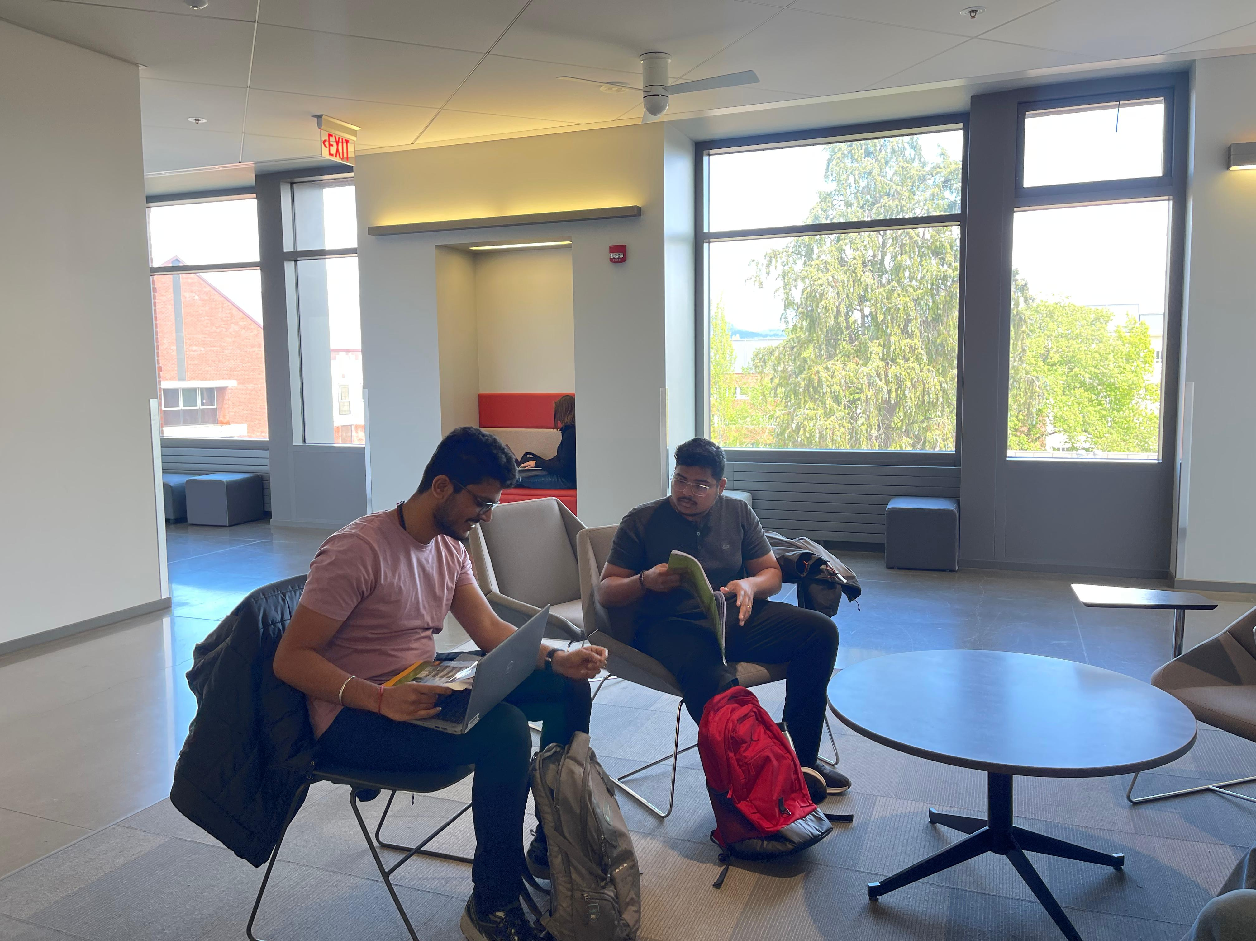

*Interactions with devices:*

* During the interview, Jane had her laptop and smartphone placed on the table in front of her. She occasionally glanced at her phone, possibly checking the time or notifications, but remained focused on the conversation. When asked about specific features or experiences with the app, Jane picked up her phone and navigated to the relevant screens to provide visual examples or to refresh her memory.
* Jane's backpack appeared well-worn and had several patches and pins, indicating her involvement in various campus activities or organizations.
* She had a reusable water bottle on the table, suggesting she is environmentally conscious.
* Jane's laptop had several stickers on the cover, further showcasing her personality and interests.
* She spoke in a clear and confident manner, using technical terms and app-specific language comfortably, which suggested a level of technical proficiency.

**Interview answers.**

* Hi there! My day's been pretty good, thanks for asking. Just finished up a lab report, so I'm feeling Fu.
* Yeah, I have a biology midterm on Thursday. I've been studying pretty hard for it, so I'm hoping all the prep work will pay off.
* Well, I actually have a bike that I use for most of my trips. It's really convenient for getting to my classes and back home since I live pretty close to campus. But if I'm going somewhere a bit farther, like the library or the student union, I'll usually take the shuttle.
* Sure! When I first downloaded the app, I have to admit I got a bit carried away exploring all the features and settings. I like to know everything an app can do, even if I don't end up using all the functions. But mainly, I use the app to check shuttle schedules and plan my routes when I need to take the shuttle.
* I really like the live map that shows where the shuttles are in real-time. That's probably the feature I use the most. It's super helpful when I'm trying to time my trips. I also like that I can save my favorite routes for quick access.
* To be honest, I find the app's interface a bit clunky and not very intuitive. Sometimes I get lost in the menus trying to find a specific setting or feature. And there was this one time when the app crashed while I was in the middle of planning a route. That was really annoying, and I couldn't help but blame the developers for not making the app more stable.
* Right now, I'd have to use the OSU Shuttle app to plan the first part of my trip, and then switch over to the Corvallis bus app or website to figure out the rest. It's not the most seamless experience, and I often find myself spending too much time trying to coordinate the different legs of the trip. It can be a bit of a headache, especially if I'm in a rush.
* Oh, that would be amazing! It would make planning trips so much easier. I'd love to be able to plan my entire trip, from start to finish, in one app. I'd expect the app to show me the best route options, taking into account both shuttle and bus schedules, and provide clear instructions for any transfers I need to make. Real-time updates on delays or changes to the schedules would also be super helpful.
* Definitely real-time updates and accurate schedule information. Those are key. I also appreciate clear, step-by-step directions, especially when I need to make transfers or navigate unfamiliar parts of the campus or city. Estimated travel times are also helpful for planning my day and making sure I arrive on time to my classes or meetings.
* As I mentioned earlier, I find the current interface a bit confusing at times. The navigation could definitely be streamlined and made more user-friendly. I'd love to see a more modern, sleek design that makes it easier to access the features I use most often. Something that's visually appealing and easy to navigate would be a big improvement.
* The app should definitely be compatible with screen readers and other assistive technologies. Options for adjusting the font size and contrast would also be helpful for users with visual impairments. And as someone who likes to explore all the features of an app, I think clear labeling and descriptions of each function would be beneficial for all users, not just those with accessibility needs.
* Sure! One positive experience I had was when I was running late for class and needed to find the quickest shuttle route. The app's live map feature helped me see where the nearest shuttle was and when it would arrive at my stop. That saved me a lot of time and stress. On the other hand, I once spent nearly 30 minutes trying to figure out how to customize my route preferences in the app's settings. The options were buried under several layers of menus, and the labels weren't very clear. That was a frustrating experience, and I ended up being late to my meeting because of it.
* My top priorities would be a more intuitive interface, integrated multi-modal trip planning, and real-time updates. I'd also love to see more customization options, like being able to set my preferred walking speed for estimated travel times or getting notifications for specific routes or stops. My ideal version of the app would be sleek, easy to navigate, and packed with features that make my commute as seamless and stress-free as possible, whether I'm using my bike or taking the shuttle.
* You know, I really like the Citymapper app. It has a clean, modern interface and does a great job of integrating multiple modes of transportation into its route planning. The clear, step-by-step instructions and real-time updates on delays or disruptions are also really helpful. If the OSU Shuttle app could incorporate some of those design elements and features, I think it would be a huge improvement.
* I think it's really important to involve students like myself in the redesign process. We're the ones using the app on a daily basis, so our input should be valuable. I'd also suggest conducting thorough user testing to ensure that the new interface and features are intuitive and user-friendly. Oh, and please make sure the app is stable and doesn't crash frequently – that's a surefire way to frustrate users like me who rely on it for our daily commutes, whether we're biking or shuttling.
* It was my pleasure! I'm excited to see how the app evolves. Thanks for including me in the process.

**With the detailed observations, point out the places that provide Results/Insights and say what they are:**

What are the answers to your research questions from the observation?

1. How do users like Jane interact with the OSU Shuttle app to plan their commutes?

Jane's interaction with the app reveals that she relies on its search functionality to find locations, indicating that this feature is crucial for users like her. However, improvements are needed to make this process more efficient and user-friendly.

1. What factors influence users' decisions when choosing a route?

Factors influencing Jane's decision include the availability of total trip duration information, which is important for her schedule planning. Additionally, real-time delay alerts would enhance her confidence in selecting a route, indicating that reliability and convenience are key factors for users like her.

What other insights did you get from this that are relevant to your "patient"?

**Issue #1: Search Functionality**

The observation highlights an issue with the app's search functionality, as Jane had trouble getting the right locations to come up at first. This suggests that the search feature may not be intuitive or user-friendly, potentially leading to user frustration and inefficiency.

**Proposals**

**Enhancement #1: Total Trip Duration**

Providing the total trip duration on the recommended route overview would be helpful, as Jane seemed to be looking for that information to assess if the route would work with her schedule. This insight suggests that adding this information could improve the user experience by providing more comprehensive route details.

**Enhancement #2: Real-time Delays or Alerts**

More prominent display of real-time delays or alerts on Jane's route within the app interface could reduce uncertainty and help her feel more confident in taking that route. This enhancement could improve user satisfaction and trust in the app's information accuracy.

**Other Insights Relevant to "Patient" (Jane):**

Jane's reliance on the app for real-time information and route planning indicates that she values convenience and efficiency in her commute.

Her need for total trip duration information suggests that she values time management and planning ahead, which could be important considerations for app developers to improve user experience.

**With the interview answers, point out the places that provide Results/Insights and say what they are:**

What are the answers to your research questions from the interview?

1. How do users like Jane interact with the OSU Shuttle app to plan their commutes?

Jane interacts with the app by appreciating its integration of multiple transit systems to provide the best overall route. However, she also desires easier comparison of different route options, suggesting that she values efficiency and flexibility in her commute planning.

1. What factors influence users' decisions when choosing a route?

Factors influencing Jane's decision include the ability to compare route options easily, access cost information, and save frequently used locations and routes. These factors indicate that user-friendly features and cost considerations play a significant role in her decision-making process.

What other insights did you get from this that are relevant to your "patient"?

* Jane's desire for a more user-friendly interface suggests that she values simplicity and ease of use in the app. This insight could inform future app developments to enhance user experience.
* Her interest in cost information and the ability to save favorite locations and routes indicates that she is proactive in her commute planning and values tools that help her manage her schedule efficiently.

**Results/Insights:**

**Enhancement #3: Comparing Route Options**

Jane appreciated how the app integrated multiple transit systems to provide the best overall route but wished it allowed her to compare a couple of different route options more easily. This insight suggests that improving the app's route comparison feature could enhance user satisfaction and decision-making.

**Enhancement #4: Displaying Cost Information**

Having the app display the cost of the trip or if Jane's student ID allows her free access to any of the transit services would be useful. This enhancement could improve the app's usability and help users like Jane make informed decisions about their commute.

**Enhancement #5: Saving Frequently Used Locations and Routes**

Jane would like a way to save or pin frequently used locations and routes within the app for quicker access. This insight indicates that adding a feature to save favorite locations and routes could improve user convenience and efficiency.

*Triangulate your Results/Insights from the observation and interview data with your Heuristic Evaluation by stating and numbering which issues/bugs were common to both with an ID number.*

**Issue/Enhancement #1: Search Functionality**

Both the observation and the interview data highlight a usability issue with the app's search functionality, indicating that this is a common problem experienced by users like Jane. This aligns with the previously identified Search usability issue.

**Enhancement #2: Real-Time Updates**

The need for more prominent display of real-time delays or alerts on Jane's route within the app interface, as mentioned in the interview data, aligns with the heuristic evaluation's recommendation for more Real-Time Updates.

**Enhancements #3 and #5: Flexibility and Efficiency of Use**

Jane's desire for easier comparison of different route options and the ability to save or pin frequently used locations and routes within the app, as mentioned in the interview data, aligns with the heuristic evaluation's emphasis on Flexibility and Efficiency of Use.